Q1. Table animation

<!DOCTYPE html>

<html lang="en">

<head>

<meta charset="UTF-8">

<meta name="viewport" content="width=device-width, initial-scale=1.0">

<script src="https://ajax.googleapis.com/ajax/libs/jquery/3.7.1/jquery.min.js"></script>

<title>Table and Image</title>

<style>

\* {

margin: 0;

padding: 0;

box-sizing: border-box;

}

body {

font-family: Arial, sans-serif;

background-color: #f4f4f9;

display: flex;

justify-content: center;

align-items: center;

min-height: 100vh;

padding: 2rem;

}

.main {

display: flex;

justify-content: center;

align-items: center;

flex-direction: column;

border: 1px solid #ccc;

border-radius: 1rem;

background-color: #fff;

box-shadow: 0 4px 10px rgba(0, 0, 0, 0.1);

padding: 2rem;

width: 100%;

max-width: 600px;

transition: transform 1s ease-in-out;

position: relative; /\* Add relative positioning for animation \*/

}

.container {

display: flex;

justify-content: space-between;

align-items: center;

gap: 2rem;

margin-bottom: 1rem;

}

img {

width: 15rem;

border-radius: 8px;

}

table {

width: 100%;

border-collapse: collapse;

}

table, tr, td {

border: 1px solid #ddd;

padding: 1rem;

text-align: center;

}

td {

background-color: #fafafa;

}

tr:nth-child(odd) > td {

background-color: #beffae;

}

tr:nth-child(even) > td{

background-color: #7decb8; /\* Darker shade for even rows \*/

}

button {

background-color: #4CAF50;

color: white;

padding: 10px 20px;

border: none;

border-radius: 8px;

cursor: pointer;

font-size: 1rem;

transition: background-color 0.3s;

}

button:hover {

background-color: #45a049;

}

</style>

</head>

<body>

<div class="main" id="mainDiv">

<div class="container">

<div class="item">

<table>

<tr>

<td>1</td>

<td>2</td>

<td>3</td>

</tr>

<tr>

<td>4</td>

<td>5</td>

<td>6</td>

</tr>

<tr>

<td>7</td>

<td>8</td>

<td>9</td>

</tr>

</table>

</div>

<div class="item">

<img src="image.jpg" alt="Image" />

</div>

</div>

<div class="container">

<button id="moveButton">Click Here!</button>

</div>

</div>

<script>

$(document).ready(function() {

$('#moveButton').click(function() {

$('#mainDiv').animate({

left: '-300px'

}, 1000);

});

});

</script>

</body>

</html>

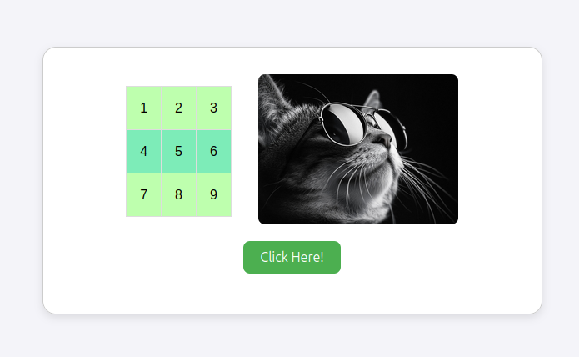

Q2. Calculator

<!DOCTYPE html>

<html lang="en">

<head>

<meta charset="UTF-8">

<meta name="viewport" content="width=device-width, initial-scale=1.0">

<title>Calculator</title>

<link href="./style.css" rel="stylesheet" type="text/css">

<style>

body {

font-family: 'Franklin Gothic Medium', 'Arial Narrow', Arial, sans-serif;

font-size: larger;

}

.main-container {

display: flex;

height: 90vh;

justify-content: center;

align-items: center;

}

.container {

width: auto;

display: flex;

gap: 15px;

flex-direction: column;

}

.header {

width: auto;

display: flex;

justify-content: space-between;

}

.title {

display: flex;

align-items: end;

}

.theme {

display: flex;

flex-direction: column;

}

.theme-toggler {

display: flex;

justify-content: space-around;

align-items: center;

gap: 1px;

padding: 5px;

border-radius: 50px;

}

.theme-number {

display: flex;

justify-content: space-around;

gap: 3px;

padding: 2px;

}

.theme-label-1,

.theme-label-2,

.theme-label-3 {

text-align: center;

width: 20px;

height: 20px;

}

.theme1,

.theme2,

.theme3 {

width: 20px;

height: 15px;

border-radius: 30px;

;

}

.theme1:hover,

.theme2:hover,

.theme3:hover {

background-color: rgba(255, 255, 255, 0.221);

}

.screen {

width: auto;

height: 5rem;

border-radius: 0.5rem;

border: none;

text-align: right;

display: flex;

justify-content: end;

align-items: center;

padding: 0.5rem;

font-size: 2.5rem;

overflow-x: auto;

}

.numpad {

display: flex;

justify-content: center;

align-items: center;

padding: 1rem;

flex-direction: column;

gap: 15px;

border-radius: 5px;

}

.numpad-number {

display: grid;

justify-self: center;

align-self: center;

width: 100%;

grid-template-columns: 1fr 1fr 1fr 1fr;

gap: 0.9rem;

text-align: center;

}

.number,

.delete,

.operator {

width: 5rem;

height: 2.5rem;

font-size: 1.5rem;

display: flex;

justify-content: center;

align-items: center;

border-radius: 5px;

}

.numpad-operate {

font-size: 1.5rem;

display: grid;

width: 100%;

column-gap: 0.9rem;

grid-template-columns: 1fr 1fr;

text-align: center;

}

.operate {

width: 95%;

height: 2.5rem;

display: grid;

justify-self: center;

align-items: center;

border-radius: 5px;

}

.btn:hover,

.operate:hover,

.delete:hover {

scale: 0.96;

transition-duration: 200ms;

cursor: context-menu;

}

.theme1-active {

background-color: hsl(6, 63%, 50%);

}

.body-theme1 {

background-color: hsl(222, 26%, 31%);

color: hsl(0, 0%, 100%);

}

.theme-toggler-theme1,

.numpad-theme1 {

background-color: hsl(223, 31%, 20%);

}

.screen-theme1 {

background-color: hsl(224, 36%, 15%);

}

.number-theme1,

.operator-theme1 {

background-color: hsl(30, 25%, 89%);

box-shadow: 0px 3px hsl(224, 28%, 35%);

color: hsl(221, 14%, 31%);

}

.operate-theme1 {

background-color: hsl(30, 25%, 89%);

box-shadow: 0px 3px hsl(224, 28%, 35%);

}

.reset-theme1,

.delete-theme1 {

background-color: hsl(225, 21%, 49%);

color: hsl(0, 0%, 100%);

}

.equal-theme1 {

background-color: hsl(6, 63%, 50%);

box-shadow: 0px 4px hsl(6, 70%, 34%);

}

.number-theme1:hover,

.operator-theme1:hover {

background-color: hsl(38, 41%, 83%);

}

.reset-theme1:hover,

.delete-theme1:hover {

background-color: hsl(223, 79%, 71%);

}

.equal-theme1:hover {

background-color: hsl(6, 76%, 69%);

}

</style>

</head>

<body>

<div class="main-container">

<div class="container">

<div class="header">

<div class="title">calc</div>

</div>

<div class="screen" id="expression"></div>

<div class="numpad">

<div class="numpad-number">

<div class="btn number" id="7">7</div>

<div class="btn number" id="8">8</div>

<div class="btn number" id="9">9</div>

<div class="delete" id="delete">DEL</div>

<div class="btn number" id="4">4</div>

<div class="btn number" id="5">5</div>

<div class="btn number" id="6">6</div>

<div class="btn operator" id="plus">+</div>

<div class="btn number" id="1">1</div>

<div class="btn number" id="2">2</div>

<div class="btn number" id="3">3</div>

<div class="btn operator" id="minus">-</div>

<div class="btn number" id="point">.</div>

<div class="btn number" id="0">0</div>

<div class="btn operator" id="divide">/</div>

<div class="btn operator" id="multiply">\*</div>

</div>

<div class="numpad-operate">

<div class="operate reset" id="reset">RESET</div>

<div class="operate equal" id="equal">=</div>

</div>

</div>

</div>

</div>

<script src="https://ajax.googleapis.com/ajax/libs/jquery/3.7.1/jquery.min.js"></script>

<script>

$("body").addClass("body-theme1");

$(".theme-toggler").addClass("theme-toggler-theme1");

$(".screen").addClass("screen-theme1");

$(".numpad").addClass("numpad-theme1");

$(".number").addClass("number-theme1");

$(".operator").addClass("operator-theme1");

$(".operate").addClass("operate-theme1");

$(".reset").addClass("reset-theme1");

$(".delete").addClass("delete-theme1");

$(".equal").addClass("equal-theme1");

var expression = "";

var result;

function displayOnScreen(exp) {

document.querySelector(".screen").innerHTML = exp;

}

document.querySelector(".reset").addEventListener("click", function () {

expression = "";

displayOnScreen(expression);

});

$(".delete").on("click", function () {

expression = expression.slice(0, expression.length - 1);

displayOnScreen(expression);

});

$(".btn").on("click", function () {

expression += this.innerHTML;

displayOnScreen(expression);

});

$(".equal").on("click", function () {

result = eval(expression);

displayOnScreen(result);

expression = result;

console.log(result);

});

</script>

</body>

</html>

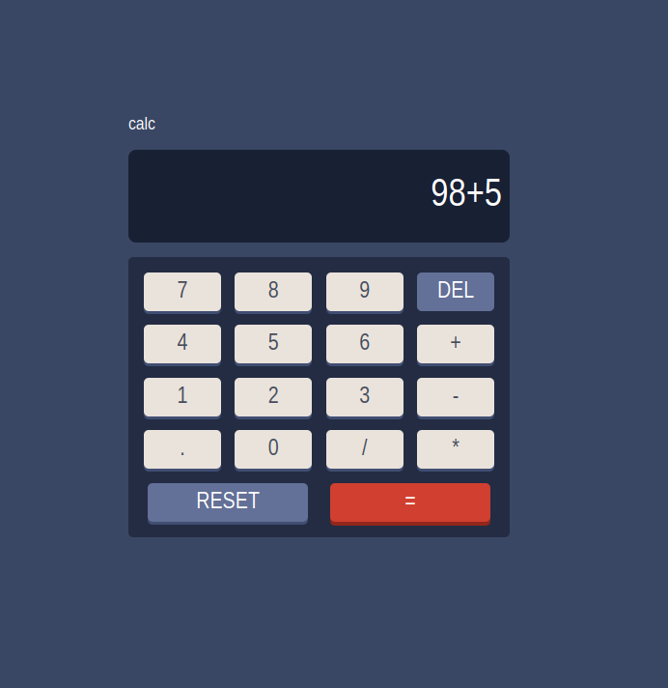  
  
Q3. Card Generator

<!DOCTYPE html>

<html lang="en">

<head>

<meta charset="UTF-8">

<meta name="viewport" content="width=device-width, initial-scale=1.0">

<script src="https://ajax.googleapis.com/ajax/libs/jquery/3.7.1/jquery.min.js"></script>

<title>Birthday Card Generator</title>

<style>

\* {

margin: 0;

padding: 0;

box-sizing: border-box;

}

body {

display: flex;

height: 100vh;

}

.form-container {

width: 50%;

padding: 20px;

background-color: #f4f4f9;

display: flex;

flex-direction: column;

gap: 20px;

justify-content: flex-start;

}

.form-container h2 {

text-align: center;

}

label {

font-size: 1.1rem;

}

input[type="color"],

input[type="text"],

textarea {

padding: 8px;

margin-top: 5px;

font-size: 1rem;

width: 100%;

border-radius: 5px;

border: 1px solid #ccc;

}

textarea {

resize: none;

height: 100px;

}

select, input[type="checkbox"] {

font-size: 1rem;

}

button {

background-color: #4CAF50;

color: white;

padding: 10px 20px;

border: none;

border-radius: 8px;

cursor: pointer;

font-size: 1.1rem;

margin-top: 20px;

}

button:hover {

background-color: #45a049;

}

.card-container {

width: 50%;

background-color: #fff;

display: flex;

justify-content: center;

align-items: center;

padding: 20px;

border: 1px solid #ccc;

}

.card {

width: 300px;

height: 400px;

border-radius: 15px;

display: flex;

flex-direction: column;

justify-content: center;

align-items: center;

padding: 20px;

transition: all 0.3s ease;

}

.card img {

width: 150px;

height: 150px;

margin-bottom: 15px;

display: none;

}

.card h1 {

margin-bottom: 15px;

font-family: 'Arial', sans-serif;

font-size: 2rem;

}

.card p {

font-family: 'Times New Roman', Times, serif;

font-size: 1.2rem;

text-align: center;

}

</style>

</head>

<body>

<div class="form-container">

<h2>Customize Your Birthday Card</h2>

<label for="bgColor">Choose Background Color</label>

<input type="color" id="bgColor" name="bgColor" value="#f7a7a7">

<label for="fontFamily">Choose Font</label>

<select id="fontFamily">

<option value="Arial">Arial</option>

<option value="Times New Roman">Times New Roman</option>

<option value="Courier New">Courier New</option>

<option value="Verdana">Verdana</option>

</select>

<label for="fontSize">Font Size</label>

<input type="number" id="fontSize" name="fontSize" value="20" min="10" max="40">

<label for="borderStyle">Border Style</label>

<select id="borderStyle">

<option value="solid">Solid</option>

<option value="dashed">Dashed</option>

<option value="dotted">Dotted</option>

</select>

<label for="addImage">Add Default Picture</label>

<input type="checkbox" id="addImage" name="addImage">

<label for="messageText">Add Message</label>

<textarea id="messageText" placeholder="Enter your birthday message here"></textarea>

<button id="generateCard">Generate Card</button>

</div>

<div class="card-container">

<div id="card" class="card">

<img id="cardImage" src="image.jpg" alt="Birthday Image">

<h1 id="cardTitle">Happy Birthday!</h1>

<p id="cardMessage">Wishing you a day filled with love, laughter, and joy!</p>

</div>

</div>

<script>

$(document).ready(function() {

$('#generateCard').click(function() {

const bgColor = $('#bgColor').val();

const fontFamily = $('#fontFamily').val();

const fontSize = $('#fontSize').val();

const borderStyle = $('#borderStyle').val();

const addImage = $('#addImage').prop('checked');

const messageText = $('#messageText').val();

$('#card').css('background-color', bgColor);

$('#card').css('border', `5px ${borderStyle} #ccc`);

$('#card').css('font-family', fontFamily);

$('#card').css('font-size', fontSize + 'px');

if (messageText.trim() === "") {

$('#cardMessage').text('Wishing you a day filled with love, laughter, and joy!');

} else {

$('#cardMessage').text(messageText);

}

if (addImage) {

$('#cardImage').show();

} else {

$('#cardImage').hide();

}

});

});

</script>

</body>

</html>

